Name:
Date:

Telling the Stories of Pu’uhonua o Hōnaunau

Student Handout

Vocabulary Terms
Archeology: the study of humans within the past
Artifact: an item made and used by people in the past
Context: where an artifact or feature was found on a site, including how deeply buried
Excavation: scientific digging at a site during which archeologists record artifacts, features, and their contexts
Feature: non-moveable parts of a site such as building ruins, firepits, or wells
Oral traditions: cultural stories and beliefs passed down verbally between generations
Site: area that contains archeological traces of people of the past, either artifacts or features

Heiau: temple
Kapu: meaning “sacred” or “forbidden” kapu were laws that governed Hawaiian life
Ki’i: carved wooden or stone images, sometimes representing gods or ancestors with mana
Mana: sacred power
Papamu: flat stone or board used to play the traditional Hawaiian game konane
Pu’uhonua o Hōnaunau: (“pu-oo-ho-new-ah oh ho-now-now”) a national historical park on Hawai’i with archeological artifacts and features from people who lived there over 400 years ago
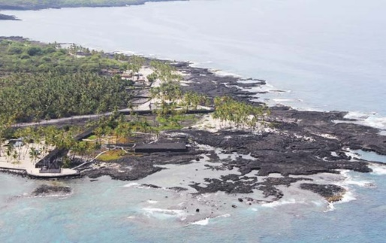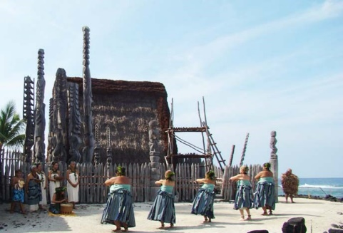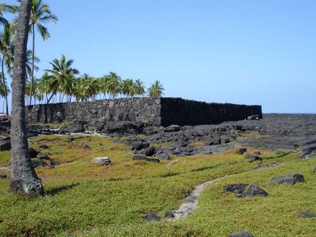
Views of Pu’uhonua o Hōnaunau. (National Park Service)

Part I: Fly-Through
Question 1) Your teacher will show you a fly-through of Pu’uhonua National Historical Park. Use the space below to list all the archeological artifacts and features that you see. While some of these do date from over 400 years ago, many were damaged over time by erosion and were recreated based on archeological evidence, oral histories, and historical documents.
Question 2) After watching the fly-through, what do you think these artifacts and features were used for?
Question 3) Based on your answer, how could these resources help archeologists understand how people of the past lived?

Part II: Touring Pu’uhonua
Your teacher will show you virtual views of four Pu’uhonua sites and review the sites’ history with you. After exploring each site, answer the discussion questions.

Site 1: Great Wall, Pu’uhonua o Hōnaunau

You are now standing inside the Great Wall of Pu’uhonua o Hōnaunau (pu-oo-ho-new-ah oh ho-now-now) National Historic Park. Archeologists believe that this site was built over 400 years ago. The Great Wall to your right is almost 1,000 feet long, 12 feet high, and 18 feet wide and was built using lava slabs, cobbles, and boulders that were fitted together. It separates the Royal Compound where chiefs and their courts lived and Pu’uhonua, the City of Refuge. Pu’uhonua protected people who broke kapu, the sacred (or “forbidden”) Hawaiian laws. To escape death, these people swam to the island and ran inside the Great Wall. If they made it inside before getting caught, a priest then performed a forgiveness ceremony that allowed them to return safely home. During times of war, families could shelter inside the Great Wall without being attacked by their enemies.
On your left is the ‘Ale’ale’a heiau, or temple. Far away past the cluster of palm trees and outside of the Great Wall is the Hale o Keawe where chiefs of the past were buried.
Question 1) When were the Great Wall and Pu’uhonua likely built?

Question 2) Which two types of people stayed here?

Question 3) How was the wall made?

Site 2: Ale’ale’a Heiau: Ka’ahumanu Stone
On your right is the Ale’ale’a heiau. The heiau was likely first built as part of the Pu’uhonua City of Refuge but later oral traditions and historical documents say that chiefs would go there to watch hula dances. On your left is a smaller stone next to the Ka’ahumanu stone. A pattern of small, carved pockets in the rock where game pieces sat showed archeologists to identify it as a papamu (stone or wood board) used to play konane, a traditional Hawaiian board game similar to checkers.
The Ka’ahumanu Stone is the large stone directly in front of you. Ka’ahumanu (1768-1832) was one of the wives of King Kamehameha I and helped rule the chiefdom for thirteen years after her husband died. Oral traditions about her were passed down through generations.
As one tradition goes, Ka’ahumanu and Kamehameha got into a quarrel one day. Fearing his anger, Ka’ahumanu left for Hōnaunau Bay with her little white dog. There, the two swam across to Pu’uhonua. Ka’ahumanu hid behind a large rock by Ale’ale’a heiau and rested while her dog climbed on top of the rock.
In the meantime, Kamehameha and his servants were following close behind. When they reached Lae Mamo village, Kamehameha thought that the villagers had hidden Ka’ahumanu in their houses. He then started setting fire to the houses. As they moved closer to the bay, one of his men saw Ka’ahumanu’s little white dog and told the chief. Kamehameha stopped burning the houses and he and his servants went around the bay towards the spot. As they came closer, the dog gave a loud bark and gave away Ka’ahumanu’s hiding place. Reunited, Ka’ahumanu and Kamehameha then made up and returned home.
While visiting Hawaii in 1866, the famous author Mark Twain wrote that the stone weighed 7 tons (14,000 pounds), was about 11 feet long, 7 feet wide, and 3 feet thick. It is illegal to alter or destroy this stone or any other artifact or feature in the park in any way.
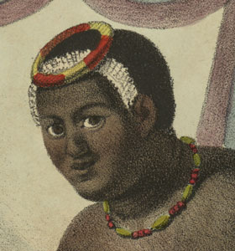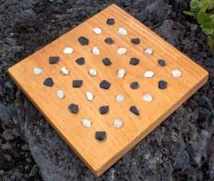
Left: Illustration of Ka’ahumanu. (Hawaii State Archives) Right: Modern papamu board with game pieces. (National Park Service)

Question 1) Which three types of evidence helped archeologists identify the Ale’ale’a heiau, Ka’ahumanu stone, and papamu?
Question 2) Why is it important to preserve these three types of materials?
Site 3: Hale o Keawe: East View and Seawalls
Hawaiian chiefs were buried at Hale o Keawe over two hundred years ago. Their mana, or sacred power, reinforced the City of Refuge’s power and importance. People would leave offerings to these chiefs to ensure their protection.
Hale o Keawe was built on a lava stone platform. A wooden palisade and several ki’i (wooden or stone statues) surrounded the building. Ki’i also had sacred power and helped protect Hale o Keawe. The ki’i that you see today are wooden figures carved in the 1960’s by local artists. All of the sacred items inside Hale o Keawe were removed in 1821 at Ka’ahumanu’s orders.
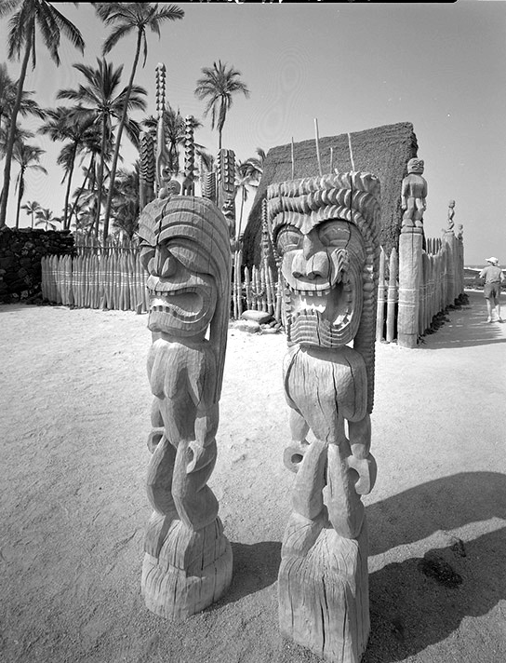
Ki’i at Hale o Keawe.
Question 1) Define ki’i.

Question 2) Imagine that Hale o Keawe stood now as it did over 200 years ago. Of the many parts of the site that you read about, which would be artifacts? Features?
Site 4: Royal Grounds: Fishponds
It is likely that only members of the royal families used this pond. Their servants would catch fish using bone hooks like the ones below. While traditional shell and bone fishhooks were still made and used after Europeans arrived in the Islands in the late 1700’s, iron fishhooks became more and more popular.
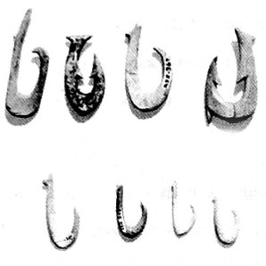
Archeological excavations at Pu’uhonua (left) and recovered fishhooks (right). (Soehren, Lloyd J. and Donald P. Tuohy.
Question 1) Examine the image of fishhooks archeologists excavated from Pu’uhonua. Have you seen anything that looks like them? Where?
Question 2) Given your answer to Question 1, write down why these fishhooks were important. What can archeologists learn from them?
Question 3) Imagine that you are an archeologist working at a site nearby Pu’uhonua and find several iron fishhooks and just one bone fishhook. How might knowing what the hook was made of help you date the site?
Question 4) Think about objects you use every day. What other artifacts or features would you look for to help understand when and how your site was used? Be creative!

Part III: Pu’uhonua o Hōnaunau, Past and Present
You have now seen how archeology and oral history can be used together to understand Pu’uhonua’s importance to past and present peoples. However, this incredible site faces many dangers. Some are caused by nature while others are from human actions. As mentioned above, it is illegal to change, destroy, remove, dig, or otherwise disturb any of the artifacts and features on this site. Even making rock or coral piles, climbing on rocks, and “coral graffiti” (spelling words with white coral pieces on the black lava rock) count as damages to these archeological resources. Please be respectful of all cultural and natural resources at this and every other park.
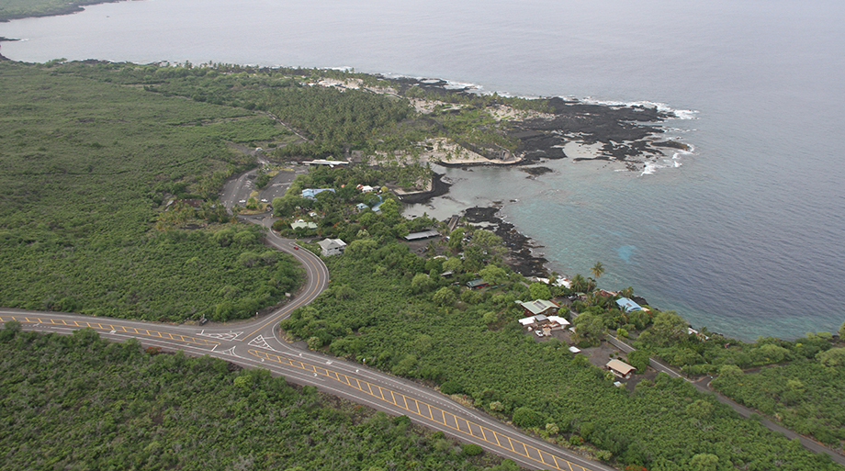
Hōnaunau Bay. (Adam Johnson, 2013 included in NPS Virtual Tour)
Question 1) The picture above shows what the site looks like today. What kinds of threats to the site do you see?

Question 2) What can archeologists and members of the public do to help preserve Pu’uhonua o Hōnaunau for future visitors?

